**Microwind Experiment**

**CMOS 12 by 4 Inverter Circuit without Capacitor-**

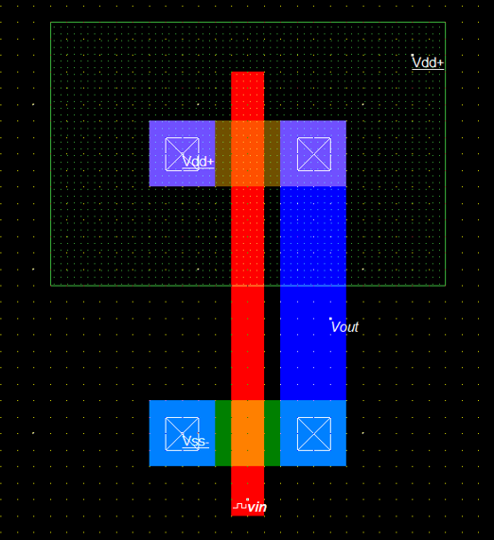

**CMOS 12 by 4 Inverter Circuit without Capacitor Waveform-**

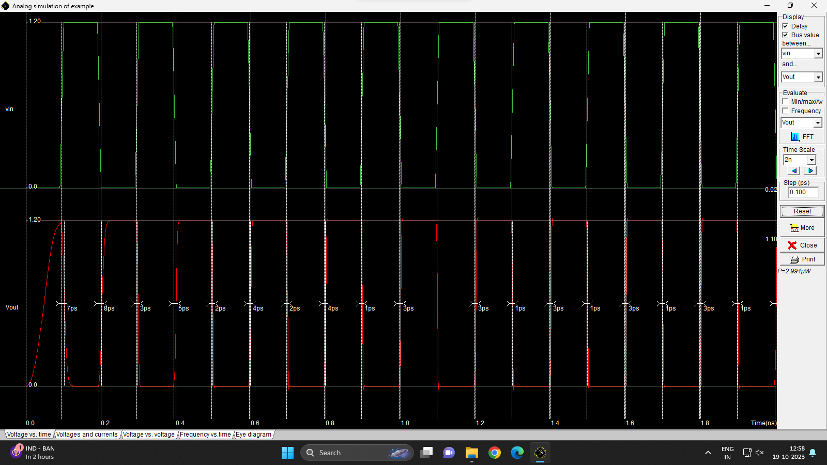

**CMOS 12 by 4 Inverter Circuit with Capacitor-**

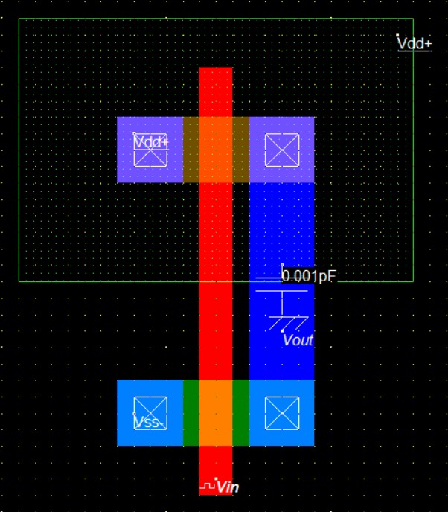

**CMOS 12 by 4 Inverter with Capacitor Waveform-**

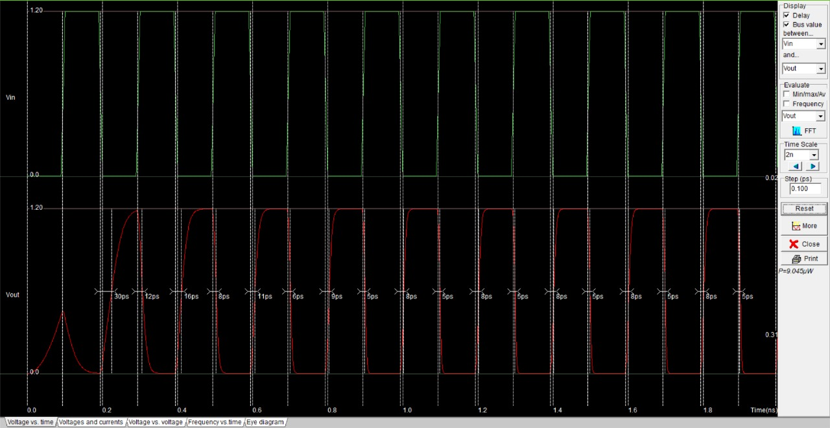

**CMOS 12 by 12 Inverter Circuit without Capacitor-**

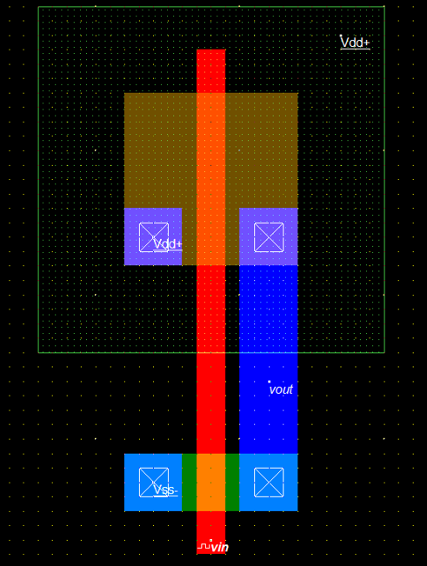

**CMOS 12 by 12 Inverter Circuit without Capacitor Waveform-**

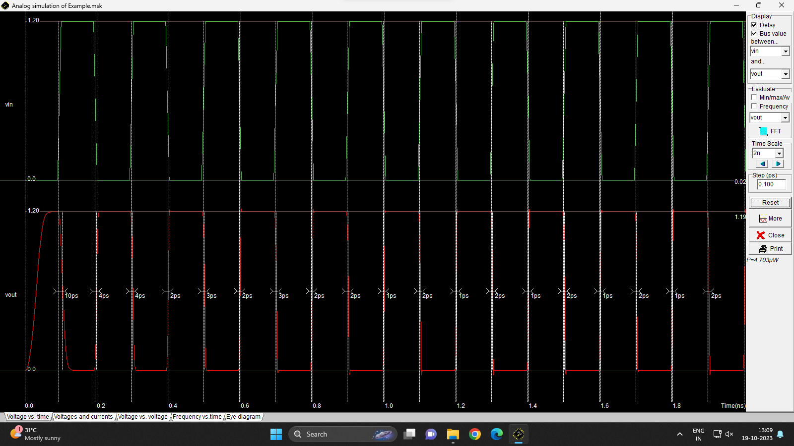

**CMOS 12 by 12 Inverter with Capacitor Circuit-**

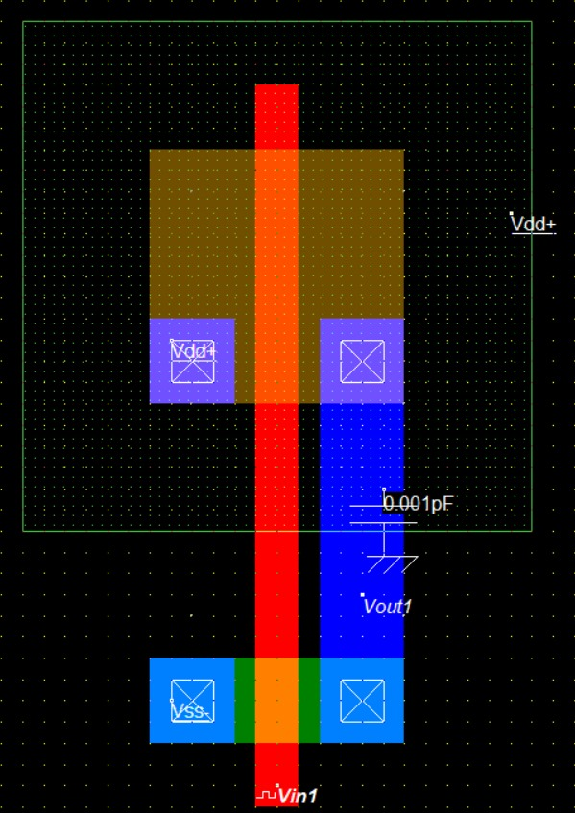

**CMOS 12 by 12 Inverter with Capacitor Waveform-**

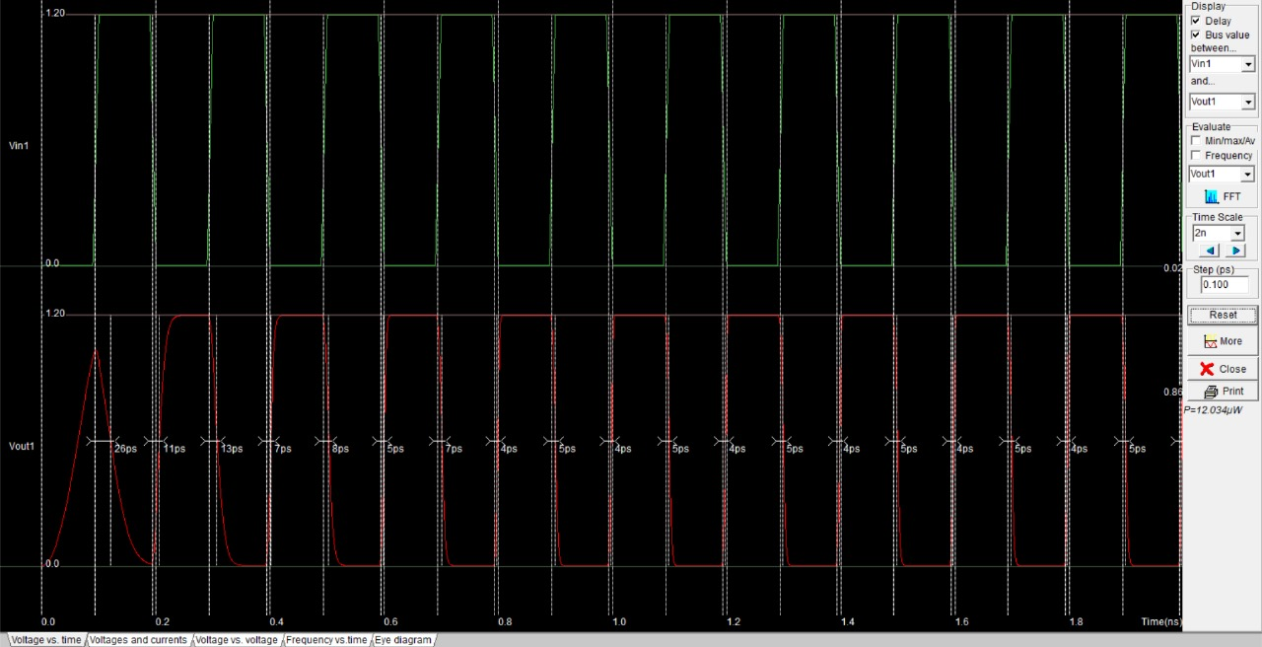

**CMOS NAND Gate Circuit-**

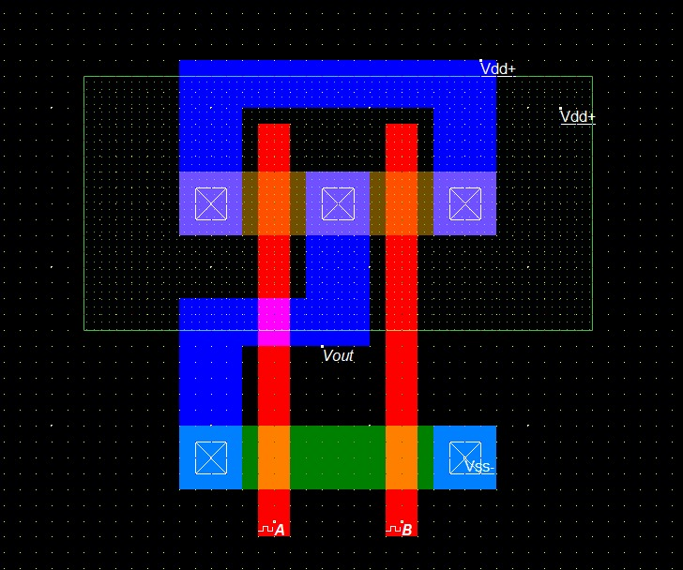

**CMOS NAND Gate Waveform-**

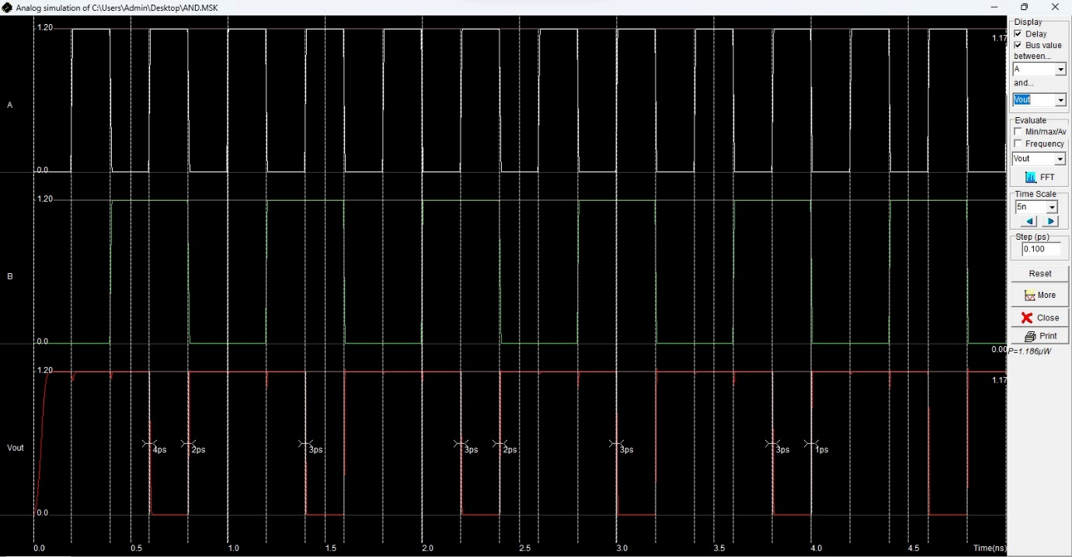

**CMOS NOR Gate Circuit-**

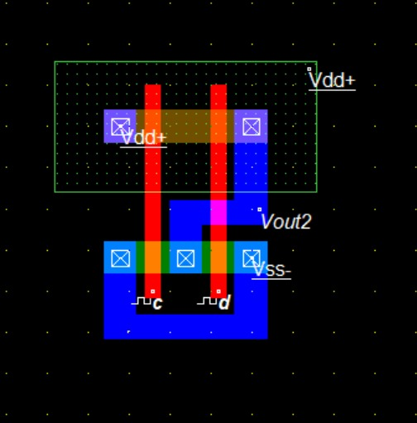

**CMOS NOR Gate Waveform-**

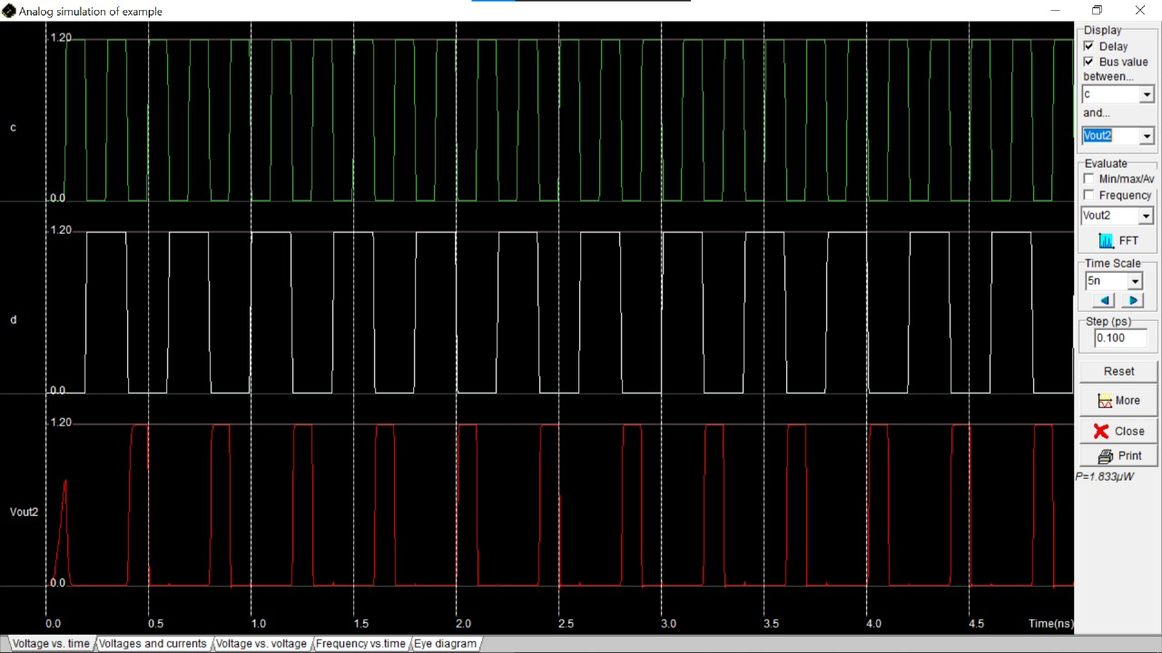

**Half Adder Sum-**

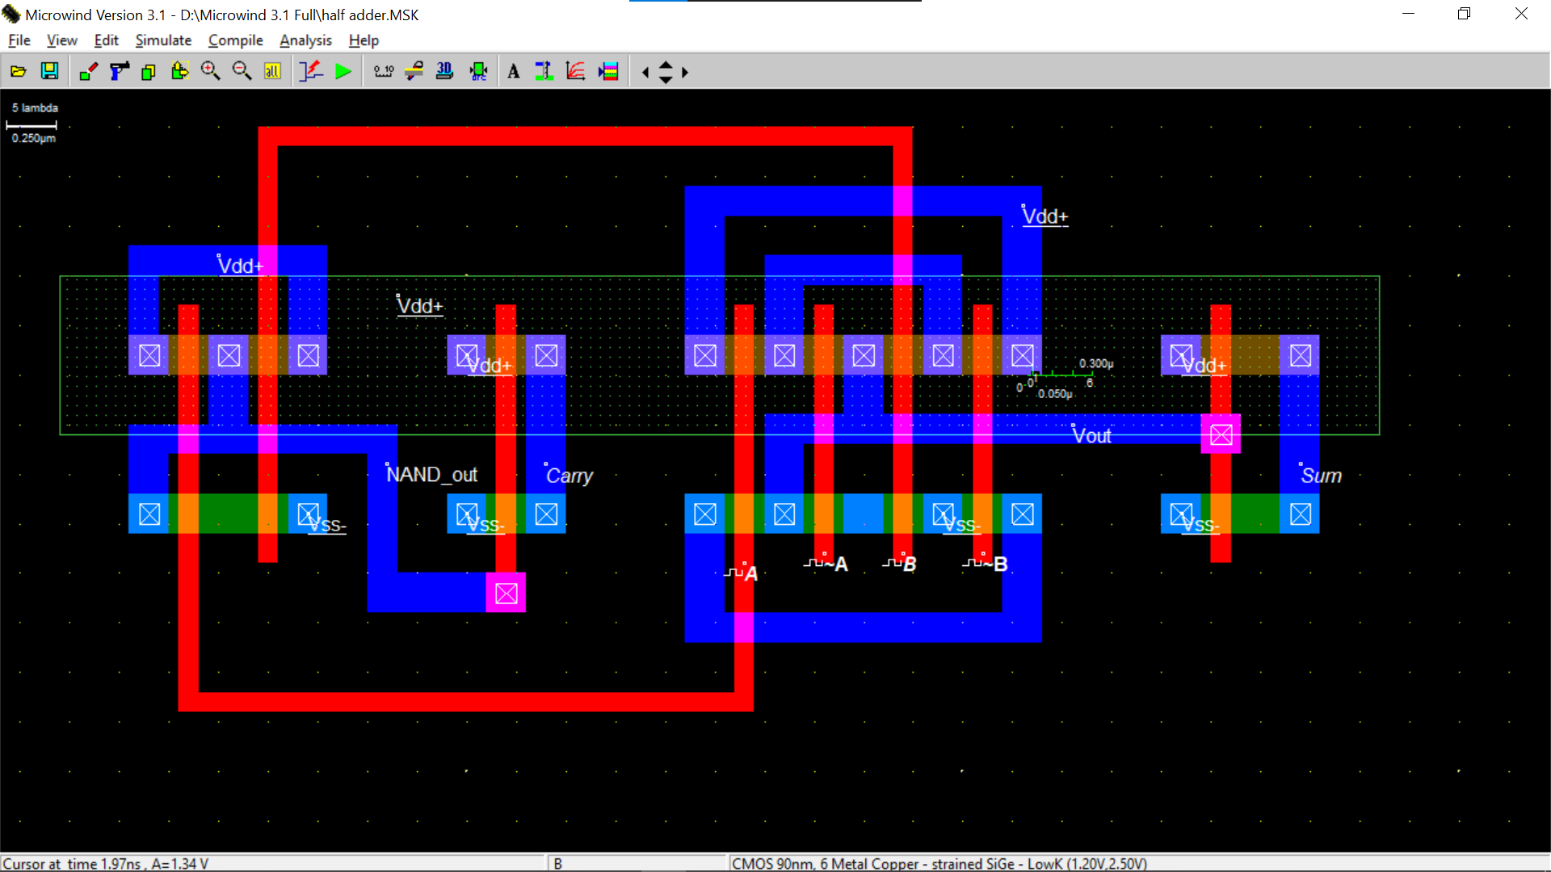

**Half Adder Waveform**

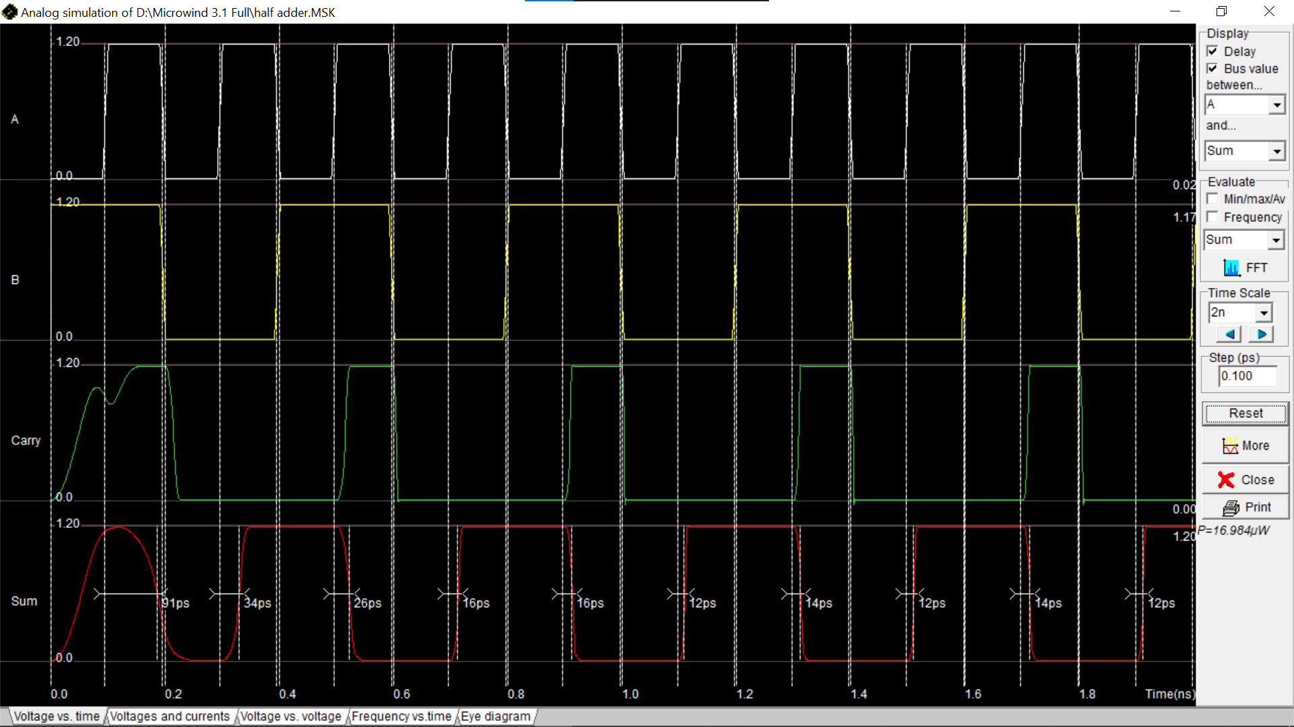-

**Full Adder Sum-**

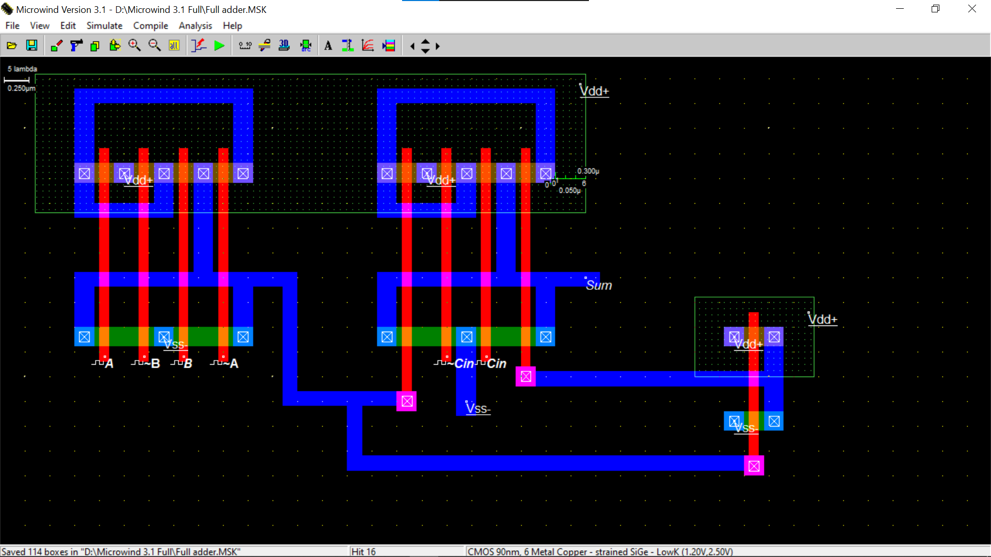

**Full Adder Carry-**

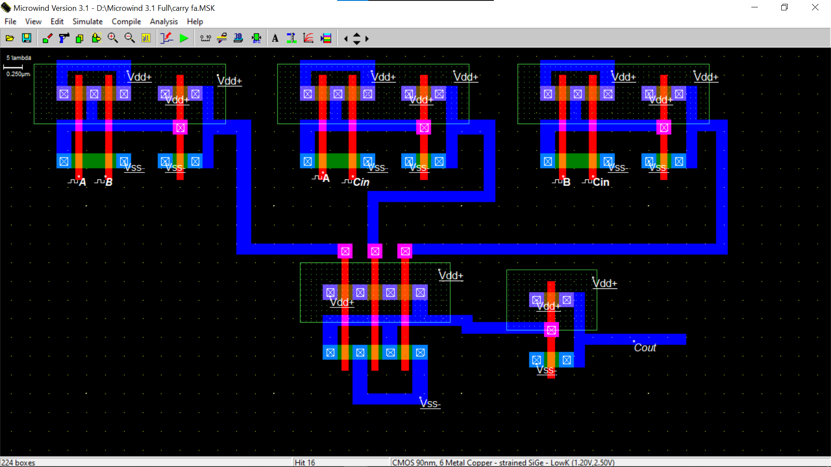

**Full Adder Waveform of Sum & Carry –**

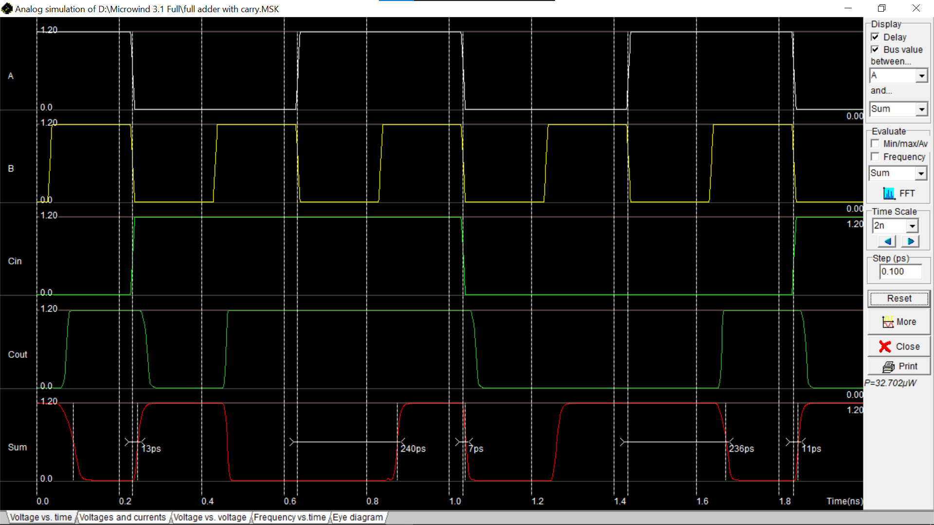

**2:1 mux using CMOS –**

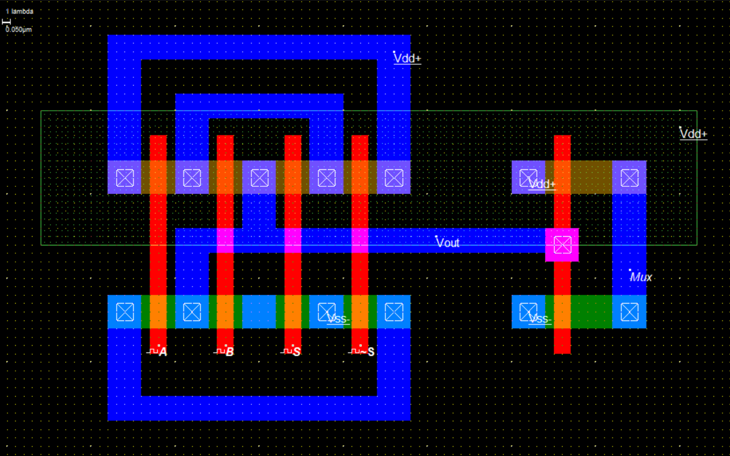

**2:1 mux using CMOS Waveform –**

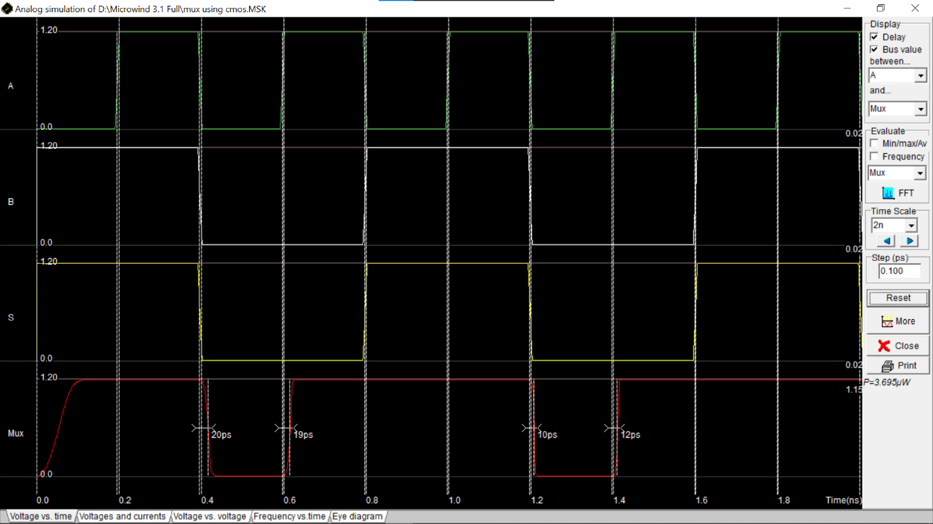

**TG (Transmission Gate) –**

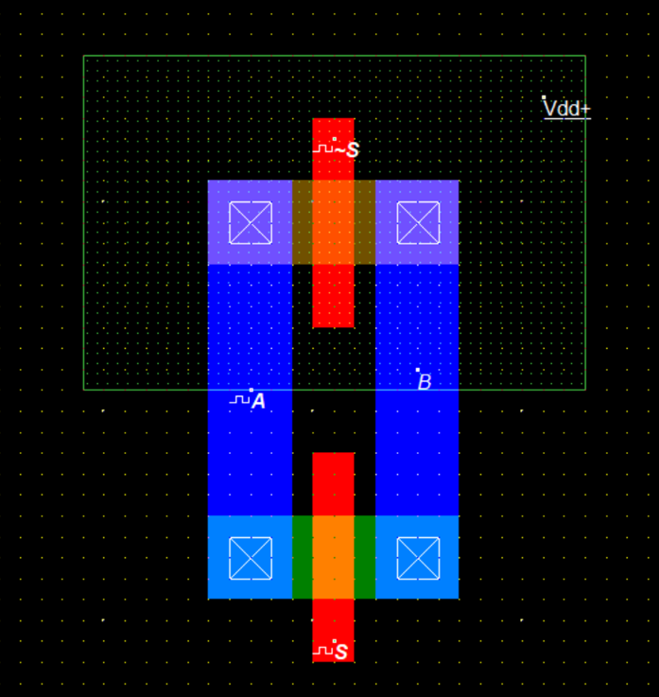

**TG (Transmission Gate) -**

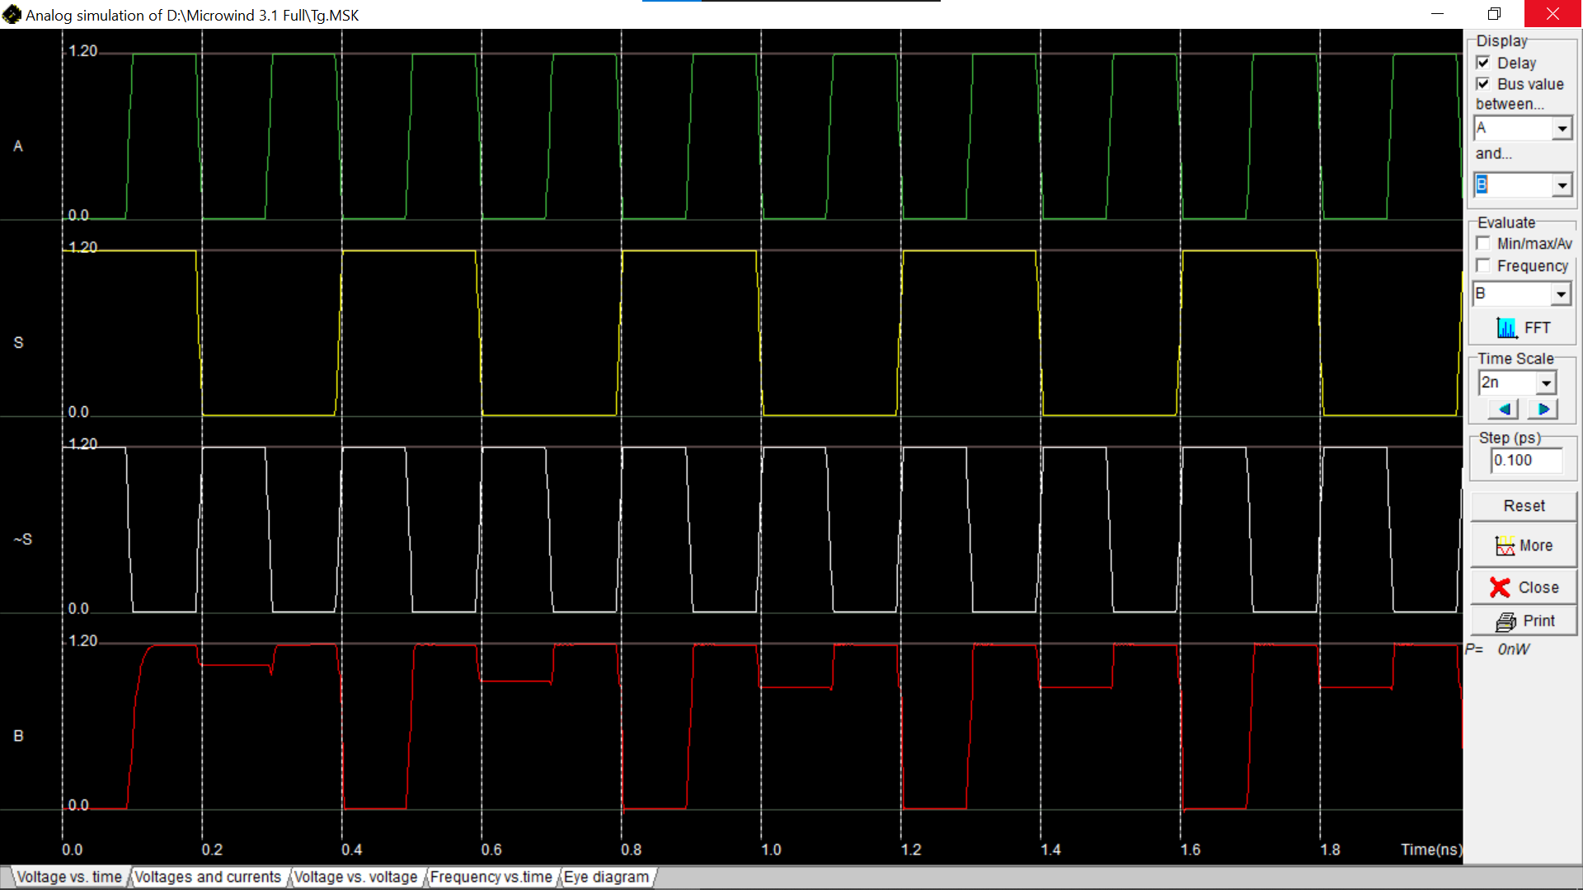

**2:1 mux using TG –**

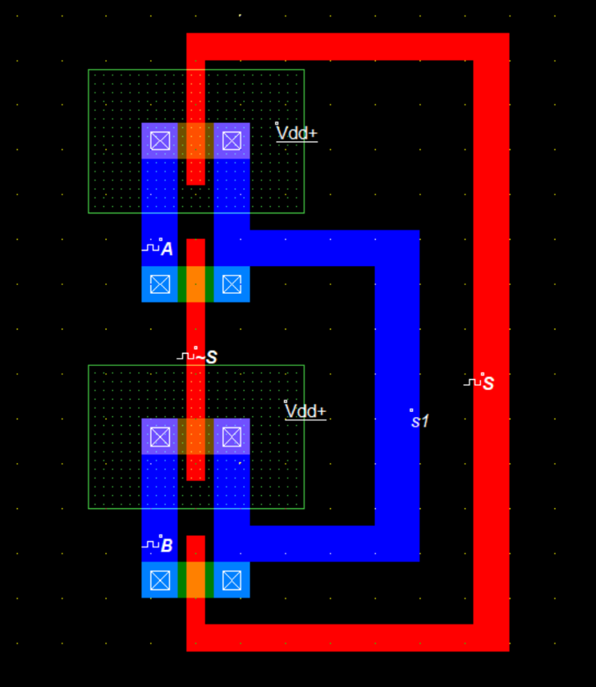

**2:1 mux using TG -**

